|  |  |  |  |  |  |
| --- | --- | --- | --- | --- | --- |
| Student Name: | Jessica Henry | Student Number: | S00214115 | Class Group: | A |

## 1. Proposed 4 Page Web Site Topic

|  |
| --- |
| On my birthday we decided to schedule a celebration dinner at Bistro Restaurant in Sligo. Problem that when booking the table, they said there was no table available on my birthday. Then we started calling several restaurants in Sligo and found a table available at a restaurant in a neighboring town. After this problem I was thinking about a solution to prevent people wasting time calling to restaurants without table available. So, my solution consist in a website where people can search for restaurants at in a city and can find all restaurants with table available – where, when, what time, how many guests.  Pages:  Home  About Us  FAQ  Contact  Login/User  Sprints management by Trello - 5 days sprints |

## 2. Proposed Design

|  |
| --- |
| [Short description of the website logo, main navigation, colours, sources of information]  Search On the psychological impact of food colour: [here](https://flavourjournal.biomedcentral.com/articles/10.1186/s13411-015-0031-3)  when I was studying about the colors, what most matched our service is the orange colour.  it was decided that this would be the theme color of the buttons.  Our logo will be a short name: Dining (Font Typo Light Oval with a dot orange)  Background #2E266F  Secondary information: #31A24C  Button: #707070  Font: #35CD8C |

## 3. Proposed Design of each page content

|  |
| --- |
| [Short description of the website content of each page, colours, text font types etc and sources]  About us: A short and fictitious history about Dining, like how many customers when it started.  Font: Type Oval Light Demo  Font Colour: Black  Size: 36  Title: Orange  FAQ: 15 questions and answers just text  Font: Type Oval Light Demo  Size: 36  Questions: Orange Bold  Answers: Black  Contact:  Font: Type Oval Light Demo  Size: 36  Font colour: Black  Login:  Font: Type Oval Light Demo  Size: 36  Font colour: Black |

## 4. Rough Proposed sketch of website home page -

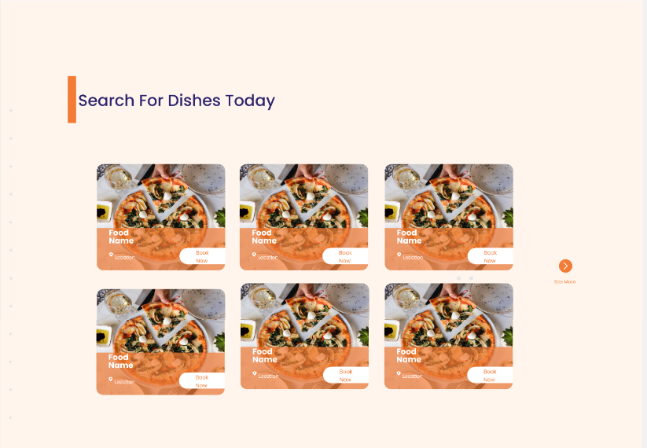

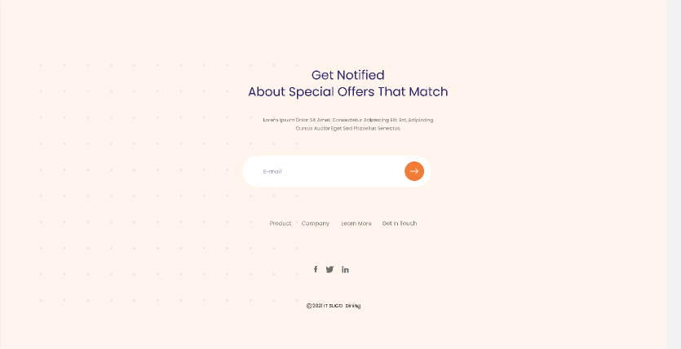

## Notes: Project outline

You will need to create a simple website on a topic of your choice. A proposed topic and design brief must be submitted on or before Monday 15/2/21 @9am. This proposal is worth 3% of your marks. Once your lecturer approves your design and marked on moodle, you can then start developing your site.

## Included in your Website

Your web site will include all of the following:-Code Comments, Code Indentation, White space, Clear consistent design, Visually attractive clear and clean and aligned. Suitable use of colours and fonts, all text and images referenced.(Public domain images). All text must be clear concise and meaningful. **Do not reference any personnel details, name etc or any reference to IT Sligo on the web pages**. Place on the following text on the home page. *This is a college project completed as part of an assignment.*

Internal and external styling (CSS), minimum of 4 html pages, appropriate use of sematic HTML 5, background and foreground images, tables, internal and external links, lists, video, a contact form, google map, bullets and radio buttons, footer on every page with Copyright notice. Also additions marks for addition features not outlined above. Project checklist and marking scheme will be available on Moodle.

## Proposal submission

* Word document upload on Moodle with sections 1-4 above completed. (Don’t forget your personal details)